SEC Form 3
FORM 3 | UNITED STATES SECURITIES AND EXCHANGE COMMISSION
 | Washington, D.C. 20549
 | Washington, D.C. 20549 |  | OMB APPROVAL
 | INITIAL STATEMENT OF BENEFICIAL OWNERSHIP OF SECURITIES
 | INITIAL STATEMENT OF BENEFICIAL OWNERSHIP OF SECURITIES |  | OMB Number: | 3235-0104
 |  |  | Estimated average burden
 | Filed pursuant to Section 16(a) of the Securities Exchange Act of 1934 |  | hours per response: | 0.5
or Section 30(h) of the Investment Company Act of 1940
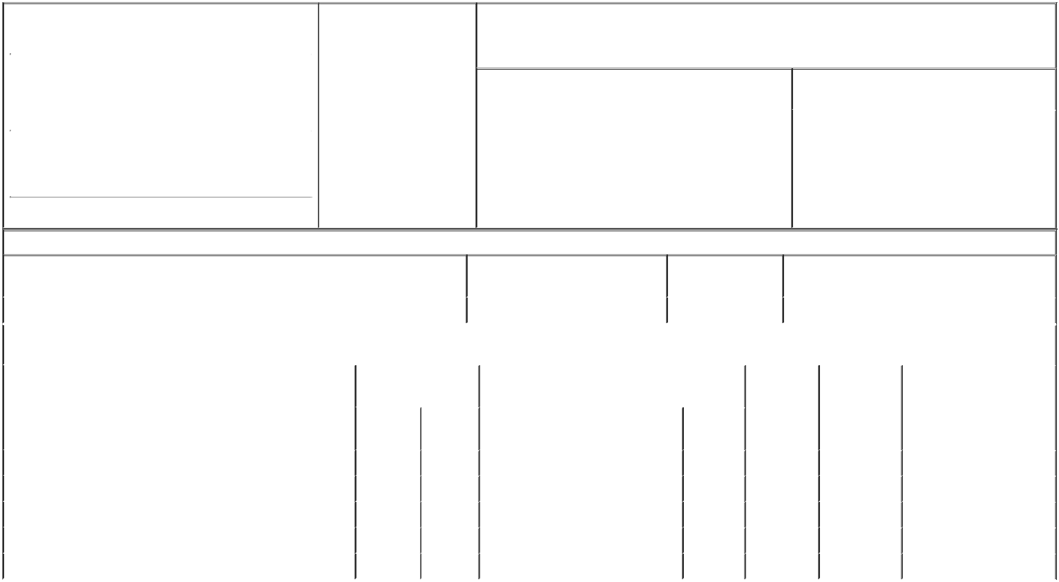

1. Name and Address of Reporting Person* |  |  |  |  | 2. Date of Event Requiring
 | Ho Mark |  |  |  | Statement (Month/Day/Year)
 | Ho Mark |  |  | 06/24/2019
 | (Last) |  | (First) | (Middle)
 | 6000 SHORELINE COURT
 | SUITE 300
(Street)
 | SOUTH SAN |  | CA | 94080
 | FRANCISCO |  | CA | 94080

3. Issuer Name and Ticker or Trading Symbol

VERACYTE, INC. [ VCYT ]

4. Relationship of Reporting Person(s) to Issuer |  |  | 5. | If Amendment, Date of Original Filed (Month/Day/Year)
(Check all applicable)
Director |  | 10% Owner
Officer (give title | X | Other (specify below) | 6. | Individual or Joint/Group Filing (Check Applicable Line)
below)
below) |  |  |  | X | Form filed by One Reporting Person
Principal Accounting Officer
Form filed by More than One Reporting Person

(City) (State) (Zip)

Table I - Non-Derivative Securities Beneficially Owned

1. Title of Security (Instr. 4) | 2. Amount of Securities Beneficially | 3. Ownership Form: | 4. Nature of Indirect Beneficial Ownership (Instr. 5)
 | Owned (Instr. 4) | Direct (D) or Indirect
 |  | (I) (Instr. 5)

 | Common Stock |  |  |  | 21,187⁽¹⁾ | D
 |  |  | Table II - Derivative Securities Beneficially Owned
 |  | (e.g., puts, calls, warrants, options, convertible securities)
 | 1. Title of Derivative Security (Instr. 4) |  | 2. Date Exercisable and |  | 3. Title and Amount of Securities Underlying |  | 4. | 5. Ownership | 6. Nature of Indirect Beneficial
 |  |  | Expiration Date |  | Derivative Security (Instr. 4) |  | Conversion | Form: Direct | Ownership (Instr. 5)
 |  |  | (Month/Day/Year) |  |  |  | or Exercise | (D) or Indirect
 |  |  |  |  |  |  | Price of | (I) (Instr. 5)
 |  |  |  |  |  | Amount or | Price of | (I) (Instr. 5)
 |  |  |  |  |  | Amount or | Derivative
 |  |  | Date | Expiration | Title | Number of | Security
 |  |  | Exercisable | Date | Title | Shares
 | Stock Option (right to buy) | (2) |  | 09/28/2025 | Common Stock | 45,000 | 4.94 | D
 | Stock Option (right to buy) | (3) |  | 02/28/2026 | Common Stock | 15,000 | 6.45 | D
 | Stock Option (right to buy) | (4) |  | 03/02/2027 | Common Stock | 25,000 | 9.05 | D
 | Stock Option (right to buy) | (5) |  | 03/01/2028 | Common Stock | 22,500 | 5.98 | D
 | Stock Option (right to buy) | (6) |  | 02/27/2029 | Common Stock | 30,000 | 20.21 | D
 | Explanation of Responses:

- Includes 2,063 restricted stock units from a grant which was awarded on March 2, 2018 which vested 25% on March 2, 2019 and vests 3/48 on each quarterly anniversary thereafter subject to continuing employment of the Reporting person on each vesting date and 4,000 restricted stock units from an award on February 28, 2019 which vests 25% on February 29, 2020 and 3/48 on each quarterly vesting date thereafter subject to continuing employment of the Reporting person on each vesting date.

- The option became exercisable as to 25% of the shares on September 29, 2016 and the remaining shares vest at a rate of 1/48th of the total number of shares subject to the award for each month of continuous service thereafter.

- The option became exercisable as to 25% of the shares on March 1, 2017 and the remaining shares vest at a rate of 1/48th of the total number of shares subject to the award for each month of continuous service thereafter.

- The option became exercisable as to 25% of the shares on March 3, 2018 and the remaining shares vest at a rate of 1/48th of the total number of shares subject to the award for each month of continuous service thereafter.

- The option became exercisable as to 25% of the shares on March 2, 2019 and the remaining shares vest at a rate of 1/48th of the total number of shares subject to the award for each month of continuous service thereafter.

- The option becomes exercisable as to 25% of the shares on February 28, 2020 and the remaining shares vest at a rate of 1/48th of the total number of shares subject to the award for each month of continuous service thereafter.

Remarks:

 | /s/ Keith Kennedy as attorney-in-fact |  | 07/01/2019
 | ** Signature of Reporting Person |  | Date
Reminder: Report on a separate line for each class of securities beneficially owned directly or indirectly.
* If the form is filed by more than one reporting person, see Instruction 5 (b)(v).
** Intentional misstatements or omissions of facts constitute Federal Criminal Violations See 18 U.S.C. 1001 and 15 U.S.C. 78ff(a).
Note: File three copies of this Form, one of which must be manually signed. If space is insufficient, see Instruction 6 for procedure.
Persons who respond to the collection of information contained in this form are not required to respond unless the form displays a currently valid OMB Number.



